

Internship Domain:
Linux Fundamentals Tasks & Instructions
Name:
Muhammad Yaseen
Student ID:
CI/DEC111

Linux Fundamentals Internship

Internship Task Submission Report

TASK 2: File Permissions & User Management Project

Objective
To understand Linux users, groups, permissions, and special permission bits.

1. User & Group Creation
Commands used:
- sudo groupadd interns
- sudo useradd -m intern1
- sudo usermod -aG interns intern1
Screenshot 1:
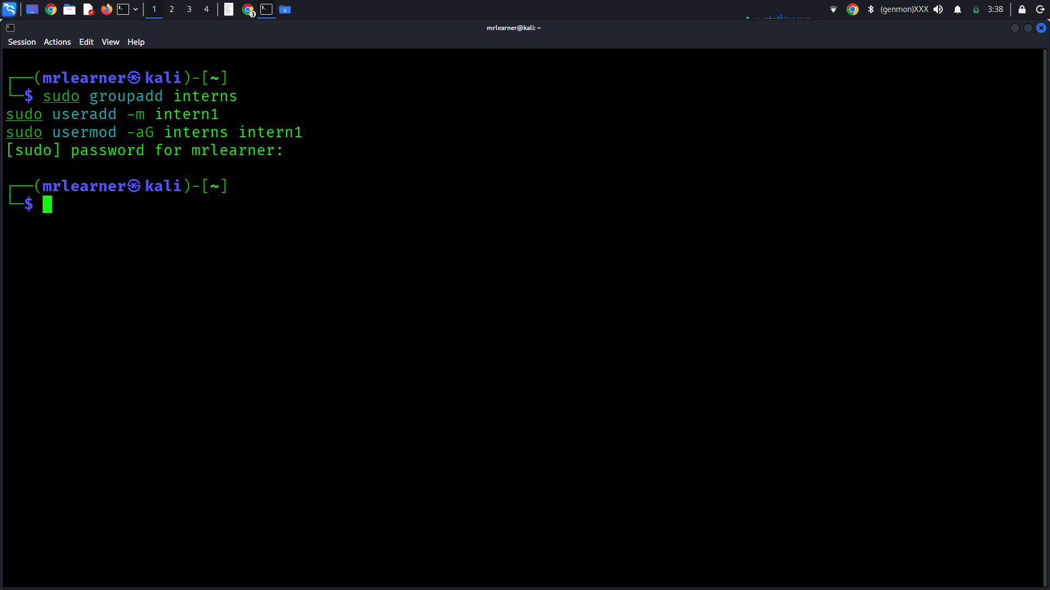

2. File Permissions
Commands used:
- touch secure.txt
- chmod 644 secure.txt
- ls -l secure.txt
Explanation:
- Read (r), Write (w), Execute (x)
- Owner, Group, Others
Screenshot 2:
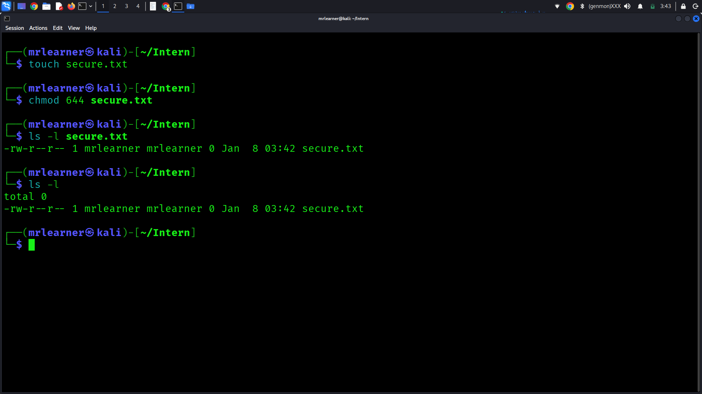
3. Ownership
Commands used:
- sudo chown intern1:interns secure.txt

Screenshot 3:
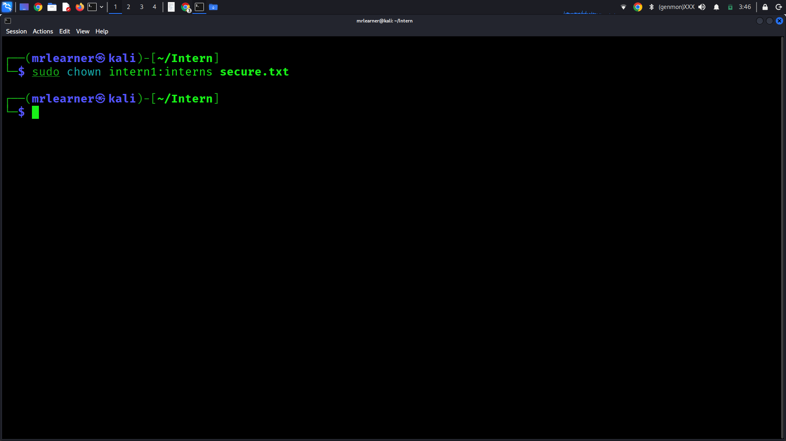
4. Special Permissions
SUID
- chmod u+s /usr/bin/passwd
SGID
- chmod g+s test_dir
Sticky Bit
- chmod +t /tmp

Screenshot 4:
